Stegocephaloidea of the NEP (Equator to Aleutians, intertidal to abyss): a review
Donald B. Cadien 19 October 2006 (revised 12 August 2007)

Introduction to the Stegocephaloidea
The superfamily Stegocephaloidea consists of only the Family Stegocephalidae, and is distributed almost entirely in cold and/or deep waters. In the past, families now allocated to the Iphimedioidea were also included here (Bousfield 1977), but their removal in the last few years has left the Stegocephalidae the sole constituent member of the superfamily (Bousfield and Shih 1994). The superfamily then has the characters of the family. The superfamily is considered to be of moderate age, originating no earlier than the middle to upper Cretaceous (Bousfield 1982b). It currently consists of over 100 species distributed among 26 genera (Berge and Vader 2001b), and has enlarged significantly over the past century (12-14 species and nine genera in Stebbing 1906).
In recent years there has been an intensive effort on the part of Jørgen Berge and Wim Vader to bring order to the nomenclatural chaos which has reigned for years in the Stegocephalidae. Their major revision (Berge & Vader 2001b) was preceded by a number of monographs addressing particular problems genus by genus, or sometimes several related genera at a time. Much still needs to be done, and their project is on-going, with new species descriptions and reinterpretations of the phylogeny still appearing (i. e. Berge and Vader 2004). On a regional basis the NEP stegocephaloids (at the time still including the odiids now removed to the Iphimedioidea) were examined by Moore (1992). His work was updated by another view of the area (this time the entire north Pacific, both east and west) by Berge and Vader (2001a)
Prior to Moore’s fairly synoptic view little had been published on regional stegocephalids beyond their original descriptions.

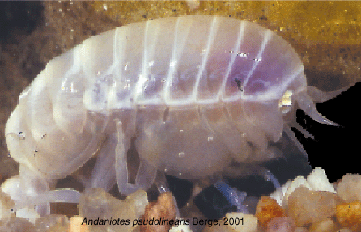
Andaniotes pseudolinearlis (photo Jørgen Berge)

Diagnosis of the Stegocephaloidea
Description (from Bousfield 1982a): “The body generally is smooth, deep, and globular. The head is short and deep, and the rostrum is very small. The eyes are deep-reniform, but often lacking. The antennal peduncles and flagella are short: in antenna 1, peduncle 1 is somewhat swollen, and the basal flagellar segments are often fused (conjoint) and brush-setose (male): the accessory flagellum is one- or two-segmented. The mouthparts are highly modified and arranged in a conelike buccal mass (suctorial or piercing?): the upper lip is distinctly notched distally: the lower lips are tall, and inner lobes are lacking. The mandibular molar is vestigial or lacking; the palp is slender or lacking; the incisor and lacinia usually are strong. In maxilla 1 the inner plate is well developed and setose; the palp is variable, often reduced, and one-segmented. In maxilla 2 the plates are setose, and 2 often is slender. The maxilliped plates are tall and/or large, and often have an inner cutting edge; the palp is slender and weakly dactylate. Coxal plates 1-4 are all large and very deep; the fourth is largest and rounded or subovate below: all are non-overlapping and arise exactly from the corresponding pereonal segments. The gnathopods are slender and weakly subchelate or simple. Pereopods 3-7 are subequal, with 7 often shortest: the bases of 5 and 6 are often linear or variously expanded, and of 7 always expanded posteriorly. The pleon side plates are deep, and the pleopods are strong. In uropods 1-3 the rami are lanceolate and subequal, with the tips extending beyond the telson about the same distance; the rami of 3 occasionally are weakly setose. The telson lobes are fused basally, the cleft is narrow, and the tips narrow sharply distally, or the lobes are fused totally into a small plate.”

Ecological Commentary
The animals are believed to spend at least a portion of their lives in the water column. This is not based on appendage morphology with lots of fall-slowing setal tufts or flattened swimming appendages, but on the common presence of oil globules under the carapace. These alter the buoyancy of the animals, allowing them to move vertically in the water column with minimum expenditure of energy. With the buoyancy taken care of by density differences, the body can be streamlined to assist in efficient motion through the water column. Virtually all stegocephalids are very smooth, and basically lenticular, with the appendages encased in expanded coxal plates. Once on a substrate the legs are protruded, but while swimming the animal is very smooth, generating minimum turbulence and drag. Species of pelagic habits are, however, frequently more elongate than lenticular (Berge and Vader 2001b). Observations in aquaria show the animals may spend relatively long periods standing on the bottom, without any tendency to burrow into the surface sediments (Enequist 1949). This probably reflects absence of the preferred host/prey in his observation containers. Clay particles found in the guts of these animals did not appear directly related to feeding.
Distribution of several stegocephalids in the water column is documented in Birstein and Vinogradov (1970) from the western part of the North Pacific. They found three species, all pelagic, living at different depths. The only one of these species which occurs in the NEP (Parandania boecki) was found in all strata between 500-1000m and 3000-4000m. This same cosmopolitan species was reported to occur at depths in the water column between 600-940m in the day, and both slightly deeper and shallower in night tows off the Canary Islands (Thurston 1976)
While the group is viewed as basically bathypelagic (Moore and Rainbow 1984), some stegocephalids have a micrograzer lifestyle which associates them with particular megabenthic prey (Arndt, 1933: Moore and Rainbow, 1984; Vader, 1984). J. L. Barnard (1967) found evidence in the gut of Parandaniexis mirabilis that it was a microcarnivore, feeding on benthic sabellid and polynoid polychaetes. Since this form also has a prominently prehensile P4, clearly adapted for clinging to something, this species may be an associate of megabenthos such as sponges, where it hunts for invertebrates associated with the host. Other evidence of a benthic existence for this animal are the presence of body ornament, the reduction of the coxae, and the robust pereopods; all atypical for the family. At least one genus (Andaniotes)is apparently adapted for scavenging, and is frequently taken in baited traps (Berge and Vader 2001b). Other genera (Andaniexis, Glorandaniotes, Parandania, Stegocephaloides)are also reported in baited traps, but with less frequency (Lowry and Smith 2003)
Information on reproduction of stegocephalids is sparse, but Stegocephalus ampulla is reportedly found with eggs in the marsupium in June in the Arctic at Svalbaard (Węsławski and Legeżyńska, 2002). By August the brood pouches are empty.

Key to NEP Stegocephaloid subfamilies

Key to the NEP subfamilies of the Stegocephalidae (derived from Berge and Vader 2001b) – D. Cadien 19 Oct 2006

1a. Antenna 1 flagellum of more than ten articles............................Parandaniinae
sole representative Parandania boecki
1b. Antenna 1 flagellum of 4-5 articles.................................................................2
2a. P4 subchelate, prehensile.............................................Parandaniexis mirabilis
sole representative of the Andaniexinae in the NEP
2b. P4 simple, without prehensally modified propod and dactyl...........................3
3a Epistomal plate present..............................................................Andaniopsinae
sole representative in the NEP Steleuthera africana
3b. Epistomal plate absent..............................................................Stegocephalinae
(see key in Berge and Vader 2001b, p. 546)

List of NEP species of the Stegocephaloidea (all in family Stegocephalidae

Alania beringi Berge and Vader 2001 – Arctic Alaska; 117m
Alania hancocki (Hurley 1956) – Oregon Slope to SCB; 200-1372m
Andaniopsis africana see Steleuthera africana
Austrocephaloides camoti (J. L. Barnard 1967) – Baja California; 791-842m
Bouscephalus mamillidacta (P. G. Moore 1992) – Aleutian Ids; 100m
Gordania pajarella (J. L. Barnard 1967) – Baja California; 1720m
Parandania boecki (Stebbing 1888) – Cosmopolitan, British Columbia;
200-2200m
Parandaniexis mirabilis Schellenberg 1929 – Baja California to Peru;
3500-3700m
Phippsiella cascadiensis see Stegocephalus cascadiensis
Phippsiella minima of Dickinson 1976 =?Stegocephalus ampulla juvenile (see
Berge and Vader 1997)
Phippsiella pajarella see Gordania pajarella
Phippsiella viscaino see Pseudo viscaina
Pseudo viscaina (J. L. Barnard 1967) – Baja California; 791-842m
Stegocephalexia penelope P. G. Moore 1992 – British Columbia; 38-45m
Stegocephalidae unknown genus and species of Barnard 1967 see Steleuthera
africana
Stegocephaloides camoti see Austrocephaloides camoti
Stegocephalopsis mamillidacta see Bouscephalus mamillidacta
Stegocephalus ampulla (Phipps 1774) – N. Atlantic, NWP, Arctic Alaska;
38-672m
Stegocephalus beringi Berge and Vader 2001 see Alania beringi
Stegocephalus cascadiensis (P. G. Moore 1992) - Cascadia Abyssal Plain off
Oregon; 2740-2818m
Stegocephalus hancocki see Alania hancocki
Stegocephalus inflatus Krøyer 1842 – N. Atlantic, NWP, Arctic Alaska;
40-2220m
Steleuthera africana Berge, Vader and Galan 2001 – South Atlantic, off Baja
California; 1720-1748m

The recent revision of the family has resulted in creation of many new genera, several represented in the NEP. All the species listed above are represented in Berge and Vader (2001a), but in several cases under different generic names. The same authors provide a key to the North Pacific species in the family which includes all described NEP species, plus a few from the NWP. The ten genera with species reported from the NEP are discussed below. Most are included in the key provided by Berge and Vader to the subfamily Stegocephalinae (2001b, pg.546). Three of the NEP species are, however, in other subfamilies and must be keyed separately. A key to separation of NEP subfamilies (4 of the 5 subfamilies recognized by Berge and Vader 2001b are represented in the NEP) was provided previously. Cladistic analysis by Berge and Vader provided a cladogram which illustrates the relationships between the generic level taxa.

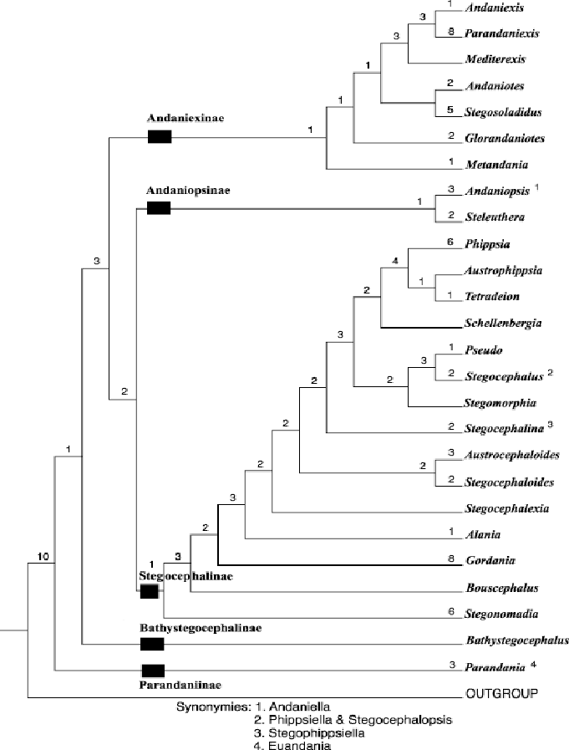

Cladogram of the genera in the Stegocephalidae based on the analysis of Berge & Vader 2001b

Alania – Created by Berge and Vader (2001b) in their family revision, this small genus contains 3 species. Two are known from the NEP, A. hancocki, the first stegocephalid described from the NEP, and A. beringi, from Arctic Alaska. Aside from the original description (Hurley 1956), A. hancocki is described in Gurjanova (1962), and in Thomas and McCann (1996). Only the original description and illustrations are available for A. beringi (Berge and Vader 2001a). It looks like Berge and Vader were going to name this genus Calypso, or at least contemplated it. In their Table 1 (Berge and Vader 2001b, pg. 553) the two listed Alania species are referred to as Calypso hancocki and Calypso beringi . These two names have no nomenclatural status, and can be ignored. I have a rather large lot of A. hancocki from the Cascadia Slope at 732m for examination.
Austrocephaloides – Another genus created by Berge and Vader (2001b), to house a clade of species formerly allocated to Stegocephaloides. They style this as a strictly southern hemisphere genus, forgetting that A. camoti, the local member, is found at bathyal depths off Baja California. The species was also not included in their review of North Pacific species (Berge and Vader 2001a), perhaps being too far to the south to meet their concept of North Pacific. It can be keyed by using the key to genera in Berge and Vader (2001b), as it is the only member of the genus in the hemisphere.
Bouscephalus – A third genus newly created in the family review of Berge and Vader (2001b). It is monotypic. The sole member is B. mamillidacta from the NEP. This species is well described and illustrated by Moore (1992), where it was originally described. As with Austrocephaloides, this animal could be keyed in the generic key (Berge and Vader 2001b), but it is also included in the North Pacific key to species provided by them (2001a), where it is listed as Stegocephaloides mamilladacta.
Gordania – Also newly minted by Berge and Vader (2001b), this genus contains only two species, one occurring in the NEP. G. pajarella is included in the North Pacific species key of Berge and Vader (2001a) as Phippsiella pajarella. It could also be separated from other regional species using the generic key in Berge and Vader 2001b, since the only other species G. minima, is from the South Pacific. Diagnostic parts are illustrated in J. L. Barnard (1967, Fig. 71), although no whole body illustration is available
Parandania – This monotypic genus consists only of the type, which is cosmopolitan in distribution. While this may suggest that undetected sibling species may be masked by the broad distribution, the bathypelagic habits of the animal make it quite conceivable that it’s reported distribution is accurate. It is illustrated both in the original Challenger description by Stebbing, and in J. L. Barnard (1961).

Parandaniexis – A genus of six species (Berge and Vader 2001b), only one known from the NEP. P. mirabilis is known from off Baja California (J. L. Barnard 1967), from off Peru (Schellenberg 1929), and also from off Spain (Andres 1977). The latter paper documents some sexual dimorphism in the structure of the prehensile pereopod 3 palm and dactyl. J. L. Barnard illustrated the animal collected off Baja California (1967, figs. 69, 70).
Pseudo – Another genus created in the family revision (Berge and Vader 2001b) for a clade previously placed in Phippsiella One NEP species is placed here, P. viscaina. It can be keyed with the North Pacific species key provided by Berge and Vader (2001a), or with the generic key provided in Berge and Vader 2001b. The other members of the genus are known from the Mediterranean, and the North Atlantic, with undescribed species identified from the Antarctic (Berge and Vader 2004). The animal is well illustrated in J. L. Barnard (1967, fig. 72).
Stegocephalexia – Created by Moore (1992), the genus remains monotypic. Either the North Pacific species key (Berge and Vader 2001a), or the generic key (Berge and Vader 2001b) could be used to arrive at an identification for this animal. Stegocephalexia penelope is illustrated only in Moore’s original description, with the exception of a few parts illustrated by Berge and Vader (2001a).

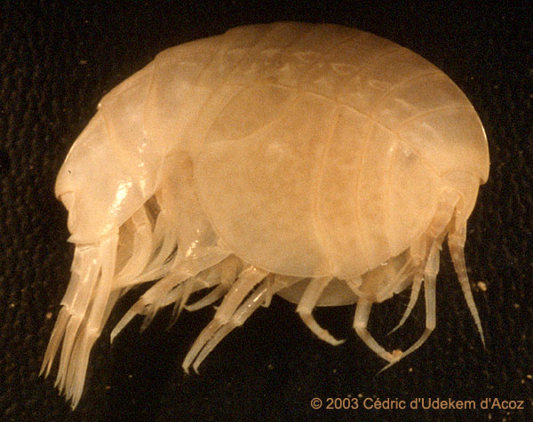

Stegocephalus inflatus (photo Cedric d’Udekem d”Acoz)

Stegocephalus - A relatively large genus for the family, with 10 described species. Four described species in the genus occur in the North Pacific, but only three are included in the North Pacific species key provided by Berge and Vader (2001a, p. 987). A key to the four known forms is provided below:.

Key to species of Stegocephalus reported from the North Pacific – D. Cadien 17 October 2006

1a. P6 basis with ventral lobe extending along ischium...................S. cascadiensis
1b. P6 basis lacking ventral lobe extending along ischium....................................2
2a. P6 basis lacking posterior lobe, scarcely wider than merus or carpus..............
..................................................................................Stegocephalus ampulla
2b. P6 basis with posterior lobe nearly twice the width of merus or carpus...........3
3a. P6 basis posterior lobe hind margin convex, smooth...................S. longicornis
(Siberian Arctic, included in key of Berge and Vader 2001a)
3b. P6 basis posterior lobe hind margin concave, minutely serrate........S. inflatum

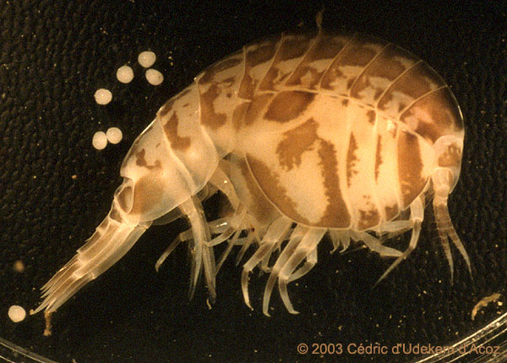
Stegocephalus inflatus, pigmented form (photo Cedric d’Udekem d’Acoz)

Steleuthera – A genus consisting of only two species; S. maremboca from the South Pacific, and S. africana, from the South Atlantic and off Baja California. The identification of the unidentified genus and species of J. L. Barnard (1967) is questionable (Berge and Vader 2001b) due to the juvenality of the specimen, but those authors found sufficient information in Barnard’s description to suggest the connection with the newly described S. africana. The distribution of this taxon seems rather odd, particularly as the other member of the genus is also known from the Pacific. Questions will remain concerning this synonymy until more developed material is obtained from the NEP to confirm or refute it. While the description of S. africana (Berge et al 2001) should be consulted if you think you have the animal, the description of the specimen examined by J. L. Barnard should also be considered (J. L. Barnard 1967).

Literature Cited

Andres, Hans Georg. 1977. Gammaridea (Crustacea, Amphipoda) aus dem Iberischen Tiefseebecken Auswertung des Materials der Fahrten 3 und 15 von F. S. "Meteor". Meteor Forschungs-Ergebnisse, Reihe D 25: 54-67.
Arndt, W. 1933. Die biologischen Beziehungen zwischen Schwämmen und Krebsen. Mitteilungen aus den Zoologischen Museum in Berlin 19: 221-305.

Barnard, J. Laurens. 1961. Gammaridean Amphipoda from depths of 400 to 6000 meters. Galathea Reports 5: 23-128.
---------.1967. Bathyal and abyssal gammaridean Amphipoda of Cedros Trench, Baja California. United States National Museum, Bulletin, no. 260: 1-205.
---------, and Gordan S. Karaman. 1991. The Families and Genera of Marine Gammaridean Amphipoda (except Marine gammaroids)[parts 1 and 2]. Records of the Australian Museum Supplement 13: 1-866.
Berge, Jorgen, and Wim Vader. 1997. North Atlantic and Mediterranean species of the genus Phippsiella Schellenberg (Amphipoda: Stegocephalidae). Journal of Natural History 31(10): 1501-1532.
---------, and ---------. 2001a. North Pacific species of the amphipod (Crustacea) family Stegocephalidae, with description of one new species and redescription of another. Journal of Natural History 35(7): 985-1000.
---------, and ---------. 2001b. Revision of the amphipod (Crustacea) family Stegocephalidae. Zoological Journal of the Linnean Society 133: 531-592.
———, and ---------. 2004. Two new Antarctic stegocephalid (Amphipoda: Stegocephalidae: Stegocephalinae) species, with implications for the phylogeny and classification of two genera Pseudo and Schellenbergia. Deep-Sea Research II 51: 1709-1716.
---------, ---------, and A. Galan. 2001. Type material of Stegocephalidae (Crustacea: Amphipoda) from the collections of the Natural History Museum, London: redescription of 6 species and description of 7 new species. The Bulletin of the Natural History Museum 67(2): 109-136
Birstein, Yakov Avand'Evich, and M. E. Vinogradov. 1970. On the fauna of pelagic gammarids in the Kurile-Kamchatka area of the Pacific Ocean. Academy of Sciences of the USSR, Proceedings of the Shirshov Institute of Oceanology 86: 419-438.
Bousfield, Edward L. 1978. A revised classification and phylogeny of amphipod crustaceans. Transactions of the Royal Society of Canada, Series 4 16: 343-90.
---------. 1982a. Malacostraca, Peracarida, Amphipoda. pp. 232-293 IN: Synopsis and Classification of Living Organisms. ed. Sybil P. Parker . New York, New York: McGraw-Hill Book Company.
———. 1982b. Amphipoda (Palaeohistory). pp. 96-100 IN: McGraw-Hill Yearbook of Science & Technology 1982/1983. New York, New York: McGraw-Hill Book Company.
———. 2001. An updated commentary on phyletic classification of the amphipod Crustacea and its application to the North American Fauna. Amphipacifica 3(1): 49-119.
---------, and Chiang-tai Shih. 1994. The phyletic classification of amphipod crustaceans: problems in resolution. Amphipacifica 1(3): 76-134.
Enequist, Paul. 1949. Studies on the soft-bottom amphipods of the Skagerak. Zoologische Bidrag Fran Uppsala 28: 297-492.
Gurjanova, Eupraxie F. 1962. Scud Shrimps (Amphipoda- Gammaridae) of the Northern Part of the Pacific Ocean. Leningrad: Academy of Sciences of the U. S. S. R. Publishing House.

Hurley, Desmond E. 1956. A new species of Stegocephalus (Amphipoda: Gammaridea) from California. Bulletin of the Southern California Academy of Sciences 55(1): 28-34.
Lowry, James K., and S. D. A. Smith. 2003. Invertebrate Scavenging Guilds along the Continental Shelf and Slope of Eastern Australia - General Description, FRDC Project 96/280. Australian Museum, Sydney, Australia. 59pp.
McLaughlin, Patsy A., David K. Camp, Martin V. Angel, Edward L. Bousfield, Pierre Brunel, Richard C. Brusca, Donald B. Cadien, Anne C. Cohen, Kathleen Conlan, Lucius G. Eldredge, Darryl L. Felder, Joseph W. Goy, Todd A. Haney, Brenda Hann, Richard W. Heard, Ed A. Hendrycks, Horton H. Hobbs III, John R. Holsinger, Brian Kensley, Diana R. Laubitz, Sara E. LeCroy, Rafael Lemaitre, Rosalie F. Maddocks, Joel W. Martin, Paula Mikkelsen, Elisabeth Nelson, William A. Newman, Robin M. Overstreet, William J. Poly, W. Wayne Price, Janet W. Reid, Andrew Robertson, D. Christopher Rogers, Arnold Ross, Marilyn Schotte, Frederick R. Schram, Chiang-Tai Shih, Les Watling, and George D. F. Wilson. 2005. Common and Scientific Names of Aquatic Invertebrates from the United States and Canada - Crustaceans. Bethesda, Maryland, U. S. A.: American Fisheries Society. 565pp.
Moore, P. Geoffrey. 1992. A Study on Amphipods from the Superfamily Stegocephaloidea Dana 1852 from the Northeastern Pacific Region - Systematics and Distributional Ecology. Journal of Natural History 26(5): 905-36.
---------, and P. S. Rainbow. 1984. Ferritin crystals in the gut caeca of Stegocephaloides christianiensis Boeck and other Stegocephalidae (Amphipoda: Gammaridea): a functional interpretation. Philosophical Transactions of the Royal Society of London, Series B 306: 219-245.
Powell, R. 1992. Biometry of brooding in seven species of amphipod (Crustacea) from the Clyde Sea area. Journal of Natural History 26(2): 353-371.
---------, and P. Geoffrey Moore. 1991. The breeding cycles of females of seven species of amphipod (Crustacea) from the Clyde Sea area. Journal of Natural History 25(2): 435-479.
Schellenberg, A. 1929. Reports...tropical Pacific...'Albatross,' from August, 1899, to March, 1900...XXII. Die Abyssale und Pelagische Gammariden. Bulletin of the Museum of Comparative Zoology, Harvard College 69(9): 193-201.
Shoemaker, Clarence R. 1955. Amphipoda collected at the Arctic Laboratory, Office of Naval research, Point Barrow, Alaska, by G.E. MacGinitie. Smithsonian Miscellaneous Collections 128(1): 1-78.
Stebbing, Thomas R. R. 1906. Amphipoda. I. Gammaridea. Das Tierreich, no. 21: 1-806.
Thomas, James Darwin, and Linda D. McCann. 1995. The Families Argissidae, Dexaminidae, Eusiridae, Gammaridae, Leucothoidae, Melphidippidae, Oedicerotidae, Pardaliscidae, Phoxocephalidae, Podoceridae, Stegocephalidae, Stenothoidae, Stilipedidae, Synopiidae, and Urothoidae. Chapter 2 Pp. 21-136 IN Taxonomic Atlas of the Benthic Fauna of the Santa Maria Basin and Western Santa Barbara Channel. The Crustacea Part 3 - The Amphipoda. James A. Blake, Les Watling, and Paul H. Scott, eds. Santa Barbara, California, U.S.A.: Santa Barbara Museum of Natural History.
Thurston, Michael H. 1976. The vertical distribution and diurnal migration of the Crustacea Amphipoda collected during the Sond Cruise, 1965. I. The Gammaridea. Journal of the Marine Biological Association of the United Kingdom 56(2): 359-382.
Vader, Wim. 1984. Notes on Norwegian marine Amphipoda 7. Amphipod associates of Geodia sponges in western Norway. Fauna Norvegica, Series A 5: 14-16.
Węsławski, Marcin, and Joanna Legeżyńska. 2002. Life cycles of some Arctic amphipods. Polish Polar Research 23(3-4): 253-264.

